Real Time & Embedded Systems

Project 1 GROUP-9

September 14, 2015

Harshdeep Singh Chawla

[hxc3427@g.rit.edu](mailto:hxc3427@g.rit.edu)

Deekshith Shenoy Manur

[ds7194@rit.edu](mailto:ds7194@rit.edu)

# Personal contributions:

Harshdeep:

* + Researching hardware functionality and register behavior
  + Researching M68HCS12 instruction set and datasheets

Deekshith:

* + Developing hardware approach
  + Researching M68HCS12 instruction set and datasheets

# Abstract:

For this project, we were required to Design and implement an embedded, standalone 68HCS12 program that will display a histogram of one thousand, rising edge pulse inter arrival times. The inter arrival time between pulses is expected to average around 1.0 millisecond, but the histogram should represent the range of 100 “buckets” between the values of 950 and 1050 microseconds.

Working:

For this project we used a Timer module and the Interrupt module of the microcontroller. We set the function generator to 1K Hz square wave to provide input to the IOS1 i.e. channel 1 of the microcontroller. The Timer control register is set in such a way to capture only rising edges. This is done by setting the Timer Control Register 3 and Timer Control register 4. The program waits for a user to press a key. After getting the input from the user, the interrupt is enabled. The interrupt function is designed to track the count of 1000 pulses and stores the measured timer values in an array of 1000 elements. The interrupt is disabled after measuring the timer values of 1000 pulses.

The counter TCNT is reset after each interrupt and the value of the timer is measured through the TC1 and stored in an array of 1000 elements. The values in the array are used to get the time period of each pulse by subtracting the timer values of consecutive pulses. The obtained time period is sorted in according to the inter-arrival time range 950 and 1050us and the bucket for the values ranging 950-1050us are stored in another array and is displayed.

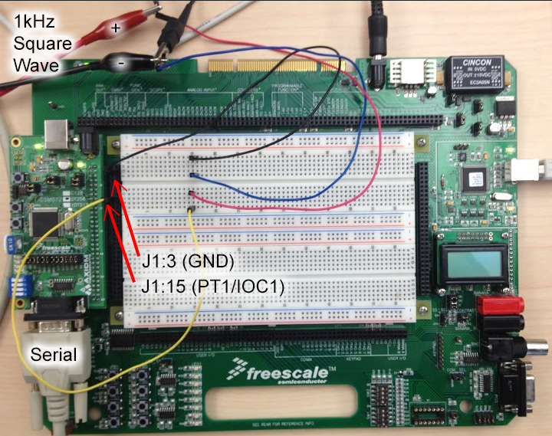

photograph of Configured Freescale Board

**Test Performed:**

**POSTROUTINE TIMER CHECK:**

We have used a POSTROUTINE function to check if the timer TCNT count is incrementing. This is done by comparing the TCNT timer value after giving some delay. If the value is the same after delay the program exits.

**Output:**

The output was taken through serial port and was displayed on the screen as shown in the image below.